NUTRITION STUDY STATISTICAL RESEARCH

Area of Study:
How do calories, age, fat, fiber, alcohol, cholesterol, smoking, and vitamin use affect body wellness? Do they vary in terms of gender, and what are the overall relationships among them? Is Cholesterol the primary response variable to all other variables that will determine the body's well-being?
Group 10
Ali Abughazaleh, Marvellous Oluwatola, Mariana Tapieros, and Shilpa Gowda

Subject
INFO:589 Applied Statistics for Business Analytics
Final Project Report
Fall 2022/2023

Dr. Ram B.Misra

Acknowledgment
“It is not possible to prepare a project report without the assistance & encouragement of other people. This one is certainly no exception.”

At the very outset of this report, we would like to extend our sincere & heartfelt obligation toward all the people who have helped us in this endeavor. Without their active guidance, help, cooperation & encouragement, we would not have made headway in the project. We are ineffably indebted to Dr. Ram B. Misra for his conscientious guidance and encouragement to accomplish this assignment. His valuable advice and recommendations were extremely exceptional. We extend our gratitude to Montclair State University for giving us this opportunity to learn and meet new people. We also acknowledge with a deep sense of reverence, our gratitude towards our parents and members of our families who have always supported us morally as well as economically. Any omission in this brief acknowledgement does not mean lack of gratitude. Thanking You!

Ali Abughazaleh
Marvellous Oluwatola
Mariana
Shilpa Gowda

Introduction

What is Nutrition?
Nutrition is the study of how food and drink affect our bodies with special regard to the essential nutrients necessary to support human health. It looks at the physiological and biochemical processes involved in nourishment, and how substances in food provide energy or are converted into body tissues. These nutrients, which are the source of energy for our bodies, are classed as carbohydrates, fats, fiber, minerals, proteins, vitamins, and water. Good nutrition means obtaining the right amount of nutrients from healthy foods in the right combinations. An important part of the study of nutrition is looking at diseases that can result from malnutrition and the role that food plays in the development of chronic disease.
https://www.schoolofhealth.com/nutrition-courses/what-is-nutrition/
Why study nutrition?
Nutrition is a critical part of health and development. Better nutrition is related to improved infant, child and maternal health, stronger immune systems, safer pregnancy and childbirth, lower risk of non-communicable diseases (such as diabetes and cardiovascular disease), and longevity. Healthy children learn better. People with adequate nutrition are more productive and can create opportunities to break the cycles of poverty and hunger gradually. Malnutrition, in every form, presents significant threats to human health. Today the world faces a double burden of malnutrition that includes both undernutrition and overweight, especially in low and middle-income countries.
There are multiple forms of malnutrition, including undernutrition (wasting or stunting), inadequate vitamins or minerals, overweight, obesity, and other in diet-related noncommunicable diseases. https://www.who.int/health-topics/nutrition#tab=tab_1
Definitions and facts about the observed data in the report and health
- Calories: The amount of energy in an item of food or drink is measured in calories.
When we eat and drink more calories than we use up, our bodies store the excess as body fat. If this continues, over time, we may put on weight. As a guide, an average man needs around 2,500kcal (10,500 kg) a day to maintain healthy body weight. For an average woman, that figure is around 2,000kcal (8,400 kg) a day. These values can vary depending on age, size, and levels of physical activity, among other factors.
https://www.nhs.uk/live-well/healthy-weight/managing-your-weight/understanding-calories/#:~:text=The%20amount%20of%20energy%20in,maintain%20a%20healthy%20body%20weight

- Fat: are also called ‘fatty acids’ or ‘lipids.’ Fats in our body are made up of three molecules joined together. This three-molecule structure is called a “triglyceride. “Too much fat in your diet, especially saturated fats, can raise your cholesterol, which increases the risk of heart disease. A small amount of fat is an essential part of a healthy, balanced diet. Fat is a source of essential fatty acids, which the body cannot make itself
https://www.nhs.uk/live-well/eat-well/food-types/different-fats-nutrition/#:~:text=A%20small%20amount%20of%20fat,with%20the%20help%20of%20fats.

- Fiber: Fiber is a type of carbohydrate that the body can’t digest. Though most carbohydrates are broken down into sugar molecules called glucose, fiber cannot be broken down into sugar molecules, and instead it passes through the body undigested. Fiber helps regulate the body’s use of sugars, helping to keep hunger and blood sugar in check. Children and adults need at least 25 to 35 grams of fiber per day for good health, but most Americans get only about 15 grams a day. Great sources are whole grains, whole fruits and vegetables, legumes, and nuts. The American Heart Association Eating Plan suggests eating a variety of food fiber sources. Total dietary fiber intake should be 25 to 30 grams a day from food, not supplements.
https://www.ucsfhealth.org/education/increasing-fiber-intake
https://www.hsph.harvard.edu/nutritionsource/carbohydrates/fiber/
- Cholesterol: is a waxy, fat-like substance that's found in all the cells in your body. Your body needs some cholesterol to make hormones, vitamin D, and substances that help you digest foods. Your body makes all the cholesterol it needs. Cholesterol is also found in foods from animal sources, such as egg yolks, meat, and cheese. If you have too much cholesterol in your blood, it can combine with other substances in the blood to form plaque. Plaque sticks to the walls of your arteries. This buildup of plaque is known as atherosclerosis. It can lead to coronary artery disease, where your coronary arteries become narrow or even blocked.
What causes high cholesterol?
The most common cause of high cholesterol is an unhealthy lifestyle. This can include:
- Unhealthy eating habits, such as eating lots of bad fats. One type, saturated fat, is found in some meats, dairy products, chocolate, baked goods, and deep-fried and processed foods. Another type, trans fat, is in some fried and processed foods. Eating these fats can raise your LDL (bad) cholesterol.
- Lack of physical activity, with lots of sitting and little exercise. This lowers your HDL (good) cholesterol.
- Smoking, which lowers HDL cholesterol, especially in women. It also raises your LDL cholesterol.

What can raise my risk of high cholesterol?

A variety of things can raise your risk for high cholesterol:
- Age. Your cholesterol levels tend to rise as you get older. Even though it is less common, younger people, including children and teens, can also have high cholesterol.
- Heredity. High blood cholesterol can run in families.
- Weight. Being overweight or having obesity raises your cholesterol level.
- Race. Certain races may have an increased risk of high cholesterol. For example, African Americans typically have higher HDL and LDL cholesterol levels than whites.

What health problems can high cholesterol cause?
If you have large deposits of plaque in your arteries, an area of plaque can rupture (break open). This can cause a blood clot to form on the surface of the plaque. If the clot becomes large enough, it can mostly or completely block blood flow in a coronary artery.
If the flow of oxygen-rich blood to your heart muscle is reduced or blocked, it can cause angina (chest pain) or a heart attack.
Plaque also can build up in other arteries in your body, including the arteries that bring oxygen-rich blood to your brain and limbs. This can lead to problems such as carotid artery disease, stroke, and peripheral arterial disease.
https://medlineplus.gov/cholesterol.html

- Alcohol: Ethanol, the active ingredient in alcoholic drinks, is generally referred to as “alcohol.” It can have powerful effects on your mental state.
https://www.healthline.com/nutrition/alcohol-good-or-bad

- Vitamin Use: Dietary supplement is an umbrella term that includes everything from vitamins and minerals to botanicals and biosimilar products (such as so-called "natural male hormone"). For the most part, though, people use "supplement" to mean an individual vitamin or mineral preparation or a multivitamin (that is, a product that contains 10 or more vitamins, minerals, or both). Even though supplements are popular, there is limited evidence that they offer any significant health benefits
https://www.health.harvard.edu/staying-healthy/do-you-need-a-daily-supplement

- Age: At the biological level, ageing results from the impact of the accumulation of a wide variety of molecular and cellular damage over time. This leads to a gradual decrease in physical and mental capacity, a growing risk of disease and ultimately death. These changes are neither linear nor consistent, and they are only loosely associated with a person’s age in years. The diversity seen in older age is not random. Beyond biological changes, ageing is often associated with other life transitions such as retirement, relocation to more appropriate housing and the death of friends and partners.
https://www.who.int/news-room/fact-sheets/detail/ageing-and-health

- Gender: Genes and chromosomes. Males and females are different from the very moment of conception. Each has 23 pairs of chromosomes, which carry the body's 20,000 to 25,000 genes. Twenty-two of these pairs are present in both males and females, but the 23rd separates the sexes. This final pair contains the sex chromosomes. In women, both members of the pair are X chromosomes, but in men one is an X and the other a Y. The Y chromosome is only about a third as large as the X and contains far fewer genes than the female sex chromosome. Some of these genes may be linked to diseases that contribute to the excess male mortality throughout life. In addition, if a woman has a disease-producing gene on one of her X chromosomes, it may be counterbalanced by a normal gene on the other X, but if a man has the same bad gene on his X chromosome, he lacks the potential protection of a matching gene.
https://www.health.harvard.edu/newsletter_article/mars-vs-venus-the-gender-gap-in-health

- Smoking: Tobacco is made from the leaves of tobacco plants. It contains nicotine, which is an addictive drug. When you smoke tobacco in cigarettes, cigars or pipes, you absorb toxic and cancer-causing chemicals that affect your health. https://www.health.gov.au/health-topics/smoking-and-tobacco/about-smoking-and-tobacco/what-is-smoking-and-tobacco

Statement of purpose
We tended to select this data set due to the importance of health care. We were fascinated to see how different significant factors, such as nutrition, habits, age, and gender, play a role in the human health system. We were also interested in understanding the association between these factors. Our primary goal in this report is to understand
1. How do Calories, age, fat, fiber, alcohol, cholesterol, smoking, and vitamin use affect body wellness?
2. Do they vary in terms of gender and age?
3. What are the overall relationships among them?
4 Is Cholesterol the primary response variable to all other variables that will determine the body's well-being?

Data Information

Variables | Type | Unit | Description
Calories | Quantitative-Ratio | Measured in kilocalories | Daily calories consumption
Fat | Quantitative-Ratio | Measured in milligrams | Fat Level
Fiber | Quantitative-Ratio | Measure in Grams | Fiber Level
Cholesterol | Quantitative-Ratio | Measured in milligrams | Cholesterol Level
Alcohol | Quantitative-Ratio | Measured by percentage.  Subcategory:  Alcohol consumption Yes or No - Binary (0=No, 1=Yes)
Age | Quantitative-Interval | Age measured in years  Categorical Subcategory:  Under 35, Between 35-50, Over50.
Vitamin Use | Categorical-Nominal | Regular, Occasional, No - Binary (0=No, 1=Others)
Smoke | Categorical-Nominal | Yes or No - Binary (0=No, 1=Yes)
Gender | Categorical-Nominal | Female and Male - Binary (0=Female, 1=Male)  42 Males / 273 Females

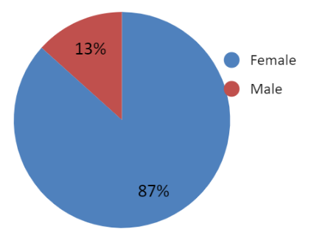
 | Female | Male | Grand Total
Grand Total | 273 | 42 | 315
 | 87% | 13%

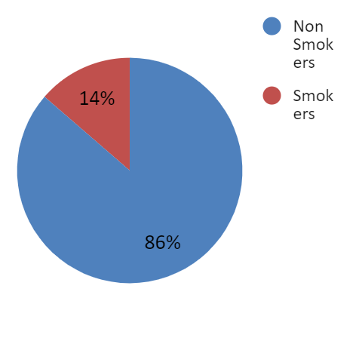
 | Female | Male | Grand Total
0 | 237 | 35 | 272
1 | 36 | 7 | 43
Grand Total | 273 | 42 | 315
Non Smokers | 87% | 83% | 86%
Smokers | 13% | 17% | 14%
Total | 87% | 13%

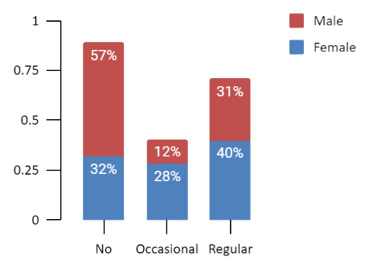
 | Female | Male | Grand Total
No | 87 | 24 | 111
Occasional | 77 | 5 | 82
Regular | 109 | 13 | 122
Grand Total | 273 | 42 | 315
 | Female | Male
No | 32% | 57% | 35%
Occasional | 28% | 12% | 26%
Regular | 40% | 31% | 39%

Average of Cholesterol | Average of Calories | Average of Fat | Average of Fiber | Average of Alcohol
242.4606349 | 1796.654603 | 77.03333333 | 12.78857143 | 3.279365079
Testing Terminologies
- T-test: an inferential test that determines if there is a significant difference between the means of two groups, used when and variance are unknown.
- Chi Square Test: test is used to determine whether there is a statistically significant difference between the expected frequencies and the observed frequencies in one or more categorical variables of a contingency table.
- ANOVA: is used to determine whether there are any statistically significant differences between the means of three or more independent (unrelated) groups
- Multivariate Regression Analysis: provides a function that describes the relationship between one or more independent variables and a response, dependent, or target variable. in another word is a way of mathematically sorting out which of those variables does indeed have an impact.
- Binary Logistic Regression Model: is a process of modeling the probability of a discrete outcome given an input variable. The most common logistic regression models a binary outcome; something that can take two values such as true/false, yes/no, and so on.
- Hypothesis: there are two main types of hypotheses,
  - H0 - The null hypothesis: It is a statement about the population that either is believed to be true or is used to put forth an argument unless it can be shown to be incorrect beyond a reasonable doubt.
  - HA - The alternative hypothesis: It is a claim about the population that is contradictory to H0 and what we conclude when we reject H0.

- Level of significance & P-value
The significance level, or alpha (α), is a value that the researcher sets in advance as the threshold for statistical significance. It is the maximum risk of making a false positive conclusion (Type I error) that you are willing to accept. In a hypothesis test, the p value is compared to the significance level to decide whether to reject the null hypothesis.
  - If the p value is higher than the significance level, the null hypothesis is not refuted, and the results are not statistically significant.
  - If the p value is lower than the significance level, the results are interpreted as refuting the null hypothesis and reported as statistically significant.

T-Tests:
We are utilizing a t-test to determine if there is a significant difference between the means of the two groups (Male and Female) in relation with cholesterol, fiber, age, fat, smoking, vitamin use, and calories.
Assumptions:
- Male and female populations are normally distributed.
- The variances of the two groups are assumed unequal.
- Data is obtained as a random sample from populations.
- The sample is large enough with more than 30 observations for both populations.
Hypothesis:
H0: u male – u female = $0$
HA: u male – u female $≠$0
Level of Significance
  - 5% level of significance
Decision Rule:
- If the p value is higher than the significance level, the null hypothesis is not rejected, and the results are not statistically significant.
- If the p value is lower than the significance level, the results are interpreted as rejecting the null hypothesis and reported as statistically significant.
*Here are the findings of one test between male and female in relation with calories.
Result: At the 5% significance level, we reject the null hypothesis since the P-value of the two-tailed test is less than 0.05. Therefore, the different intake of calories between males and females is statistically significant. We provided the rest of the p-values in the following table

Variable | P. Value | Conclusion
Age | 1.73637E-06 | Null hypothesis is rejected
Fat | 0.000959362 | Null hypothesis is rejected
Fiber | 0.379798465 | Null hypothesis is not rejected
Alcohol | 0.097555954 | Null hypothesis is not rejected
Cholesterol | 0.000116767 | Null hypothesis is rejected
Smoking | 0.575257764 | Null hypothesis is not rejected
Vitamin  * Assuming Regular /No | 0.667125462 | Null hypothesis is not rejected

Analysis
For Age, at the 5% significance level, we reject H0 since the P-value of the two-tailed test is less than 0.05. Therefore, we conclude that the difference in Age in both populations for males and females is statistically significant.
For Fat, at the 5% significance level, we reject H0 since the P-value of the two-tailed test is less than 0.05. Therefore, the fat difference for both males and females is statistically significant.
For Fiber: at the 5% significance level, we do not reject H0 since the P-value of the two-tailed test is greater than 0.05. Therefore, the fiber difference for both males and females is not statistically significant.
For Alcohol, At the 5% significance level, we do not reject H0 since the P-value of the two-tailed test is greater than 0.05. Therefore, the difference in Alcohol consumption
for both males and females is not statistically significant.
For Cholesterol, at the 5% significance level, we reject H0 since the P-value of the two-tailed test is less than 0.05. Therefore, the difference in Cholesterol for both males and females is statistically significant.
For smoking, at the 5% significance level, do not reject H0 since the P-value of the two-tailed test is greater than 0.05. Therefore, the difference in smoking for both males and females is not statistically significant
For Vitamin, at the 5% significance level, we do not reject H0 since the P-value of the two-tailed test is greater than 0.05. Therefore, the difference in vitamin intake for both males and females is not statistically significant.
Conclusion:
The experimental data findings prove that there are no significant differences in Fiber levels, smoking habits, vitamins use, and alcohol drinking between males and females. Moreover, they differ on average regarding calorie intake, Cholesterol, and Fat. We mentioned that there are biological differences between gender in how the body responds.
We also were interested in testing the sample's means in relation to smoking and not smoking. The Findings came out as follows,
1. Smokers and Nonsmokers populations are normally distributed.
2. The variances of the two groups are assumed to unequal.
3. Data is obtained as a random sample from populations.
4. The sample is large enough with more than 30 observations for both populations
Hypothesis:
H0$: u non smokers - u smokers = 0$
HA$: u non smokers - u smokers≠ 0$
Level of Significance
- 5% level of significance
Decision Rule:
- If the p value is higher than the significance level, the null hypothesis is not rejected, and the results are not statistically significant.
- If the p value is lower than the significance level, the results are interpreted as rejecting the null hypothesis and reported as statistically significant.

Variable | P. Value | Conclusion
Calories | 0.332496069 | Null hypothesis is not rejected
Age | 0.005241611 | Null hypothesis is rejected
Fat | 0.136734008 | Null hypothesis is not rejected
Fiber | 0.001508887 | Null hypothesis is rejected
Alcohol | 0.29500293 | Null hypothesis is not rejected
Cholesterol | 0.14583502 | Null hypothesis is not rejected
Gender | 0.575140254 | Null hypothesis is not rejected
Vitamin | 0.022070653 | Null hypothesis is rejected

Conclusion: We reject the null hypothesis in age, fiber, and vitamin since the p-value is less than the chosen alpha. Therefore, at a 5% significance level, we conclude that the average age, fiber level, and vitamin use between smokers and non-smokers are significantly different. On the other hand, we see that the means do not differ between smokers and non-smokers with calories, fat, alcohol, cholesterol, and gender.
Other possible T-tests
Note: t-test can also be applied if we consider testing
  - If the means for two groups of people who consume less than 1800 calories a day and those who consume greater than 1800 calories a day with the other factors differ or not.
  - If the means for two groups of people who are 50 years old or younger and those who are older than 50 years old with the other variables differ or not.

Chi-Square Test: This is a test used to determine whether there is a statistically significant difference between the expected and observed frequencies in one or more categorical variables of a contingency table. In our case, we want to identify the lifestyle habits of our sample size where we have information on the ages of our patients, where age is divided into groups Under 35, Between 35-50, and Over 50; we categorized our data in that way due to the expected frequency of each classification shall be >=5. We constructed a contingency table, shown below, that is classified by No smoke and Smoke outcome and age group. It seems that the probability of smoking habits depends on the age of our patients. Before assuming this, we want to ensure that a statistical test backs the results. For this case, we considered Chi-Square Test as the best suitable since it identifies if there is a relationship between two categorical.
Age Categories
Under 30 | Between 35-50 | Over 50

Chi Square Test 1: We wanted to test if smoking and age are dependent.
Hypothesis:
H0 = Age group and Smoking are independent.
HA= Age group and Smoking are dependent.
Level of significance
  - 5% level of significance
Decision rule:
- If the p value is higher than the significance level, the null hypothesis is not rejected, and the results are not statistically significant.
- If the p value is lower than the significance level, the results are interpreted as rejecting the null hypothesis and reported as statistically significant.
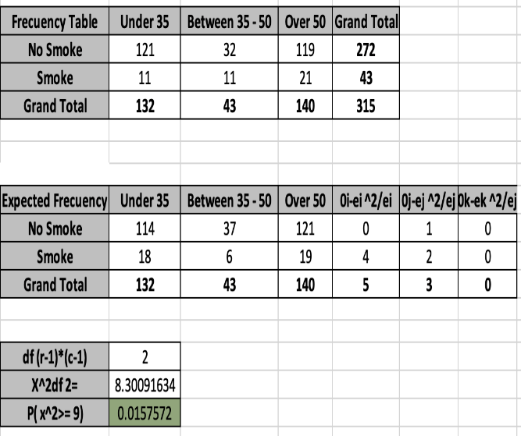
Conclusion: we found a p-value =0.015. Therefore, at the 5% significance level we conclude that we reject the null hypothesis. For instance, Age group and Smoking habits are dependent, people under 30 and over 50 are less likely to smoke than between 35-50 due to the proportion of people that smoke is 26% (11/43) which is higher than 8% (11/132) and 7% (21/140) according to our data.

Chi Square Test 2: We wanted to test if Alcohol consumption and age are dependent.
Since we are restless students, we wanted to evaluate the probability of consuming alcohol depending on the age of our patients. For this evaluation, we transformed our alcohol variable into a categorical variable, where a person's alcohol level >0 would identify an individual who drinks alcohol, and if it is =0, an individual who does not drink alcohol.
Hypothesis:
H0 = Age group and Alcohol consumption are independent.
HA= Age group and Alcohol consumption are dependent.

Level of significance
- 5% level of significance
Decision rule:
- If the p value is higher than the significance level, the null hypothesis is not rejected, and the results are not statistically significant.
- If the p value is lower than the significance level, the results are interpreted as rejecting the null hypothesis and reported as statistically significant.
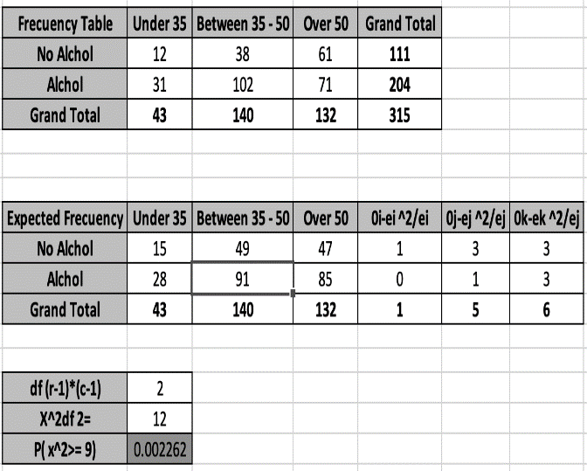
Conclusion: Since P-value =0.002262 which is less the 0.05 at the 5% significance level, we conclude that Age group and consuming alcohol are dependent according to our data.

Chi Square Tests 3: We wanted to test if Vitamin use, and age are dependent.
Finally, we want to take advantage of our data to identify more relationships between two categorical variables: age group and vitamins.
Hypothesis:
H0 = Age group and Vitamin use are independent.
HA= Age group and Vitamin use are dependent.
Level of significance
- 5% level of significance
Decision rule:
- If the p value is higher than the significance level, the null hypothesis is not rejected, and the results are not statistically significant.
- If the p value is lower than the significance level, the results are interpreted as rejecting the null hypothesis and reported as statistically significant.
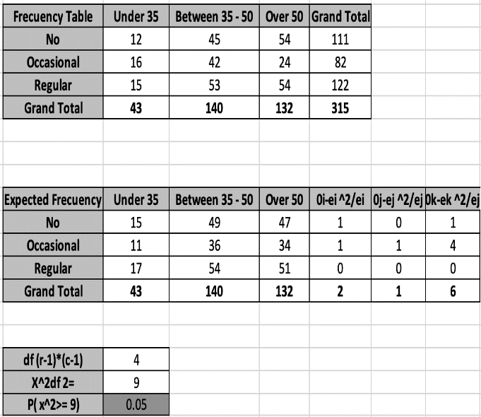
At The 5% we reject our H0, and we conclude that Age group and Vitamin use are dependent. Additionally, people between 30-50 and over 50 are more likely to use vitamins than under 35.

Possible Chi Square Tests: can also be applied if we consider testing
- If Age and 3 levels of Calories (less than 1500, between 1500 - 2500, and more than 2500 calorie) are dependent or independent.
- If Vitamin use and smoking are dependent or independent.
- If vitamin use and gender are dependent or not dependent
And many other categorical variables tests.

ANOVA
ANOVA is used to determine whether there are any statistically significant differences between the means of three or more independent (unrelated) groups.

Research Methodology
We want to compare three populations of age groups under 30, between 30-50, over 50 to compare the calories, fat, fiber and cholesterol level of them. Thus, identify if there exists any difference among them.
Assumptions
  - The data is normally distributed.
  - The population standard deviations are unknown but assumed equal.
  - Samples are selected independently.
Hypothesis
Test 1: Calories Intake vs Age Group
  - H0: All age groups consume the same amount of calories.

  - HA: At least one of the age groups consume a different amount of calories

Test 2: Fiber Intake vs Age Group

  - H0: All age groups have the same fat level.
  - HA: At least one of the age groups has different fat levels.

Test3: Fat Intake vs Age Group
  - H0: All age groups have the same fiber level
  - HA: At least one of the age groups has different fiber levels.
Test 4: Cholesterol Level vs Age Group
  - H0: All age groups have the same cholesterol level.
  - HA: At least one of the age groups has different cholesterol levels.

Level of Significance
  - 5 % level of significance.
Decision rule:
- If the p value is higher than the significance level, the null hypothesis is not rejected, and the results are not statistically significant.
- If the p value is lower than the significance level, the results are interpreted as refjectingthe null hypothesis and reported as statistically significant

Findings:
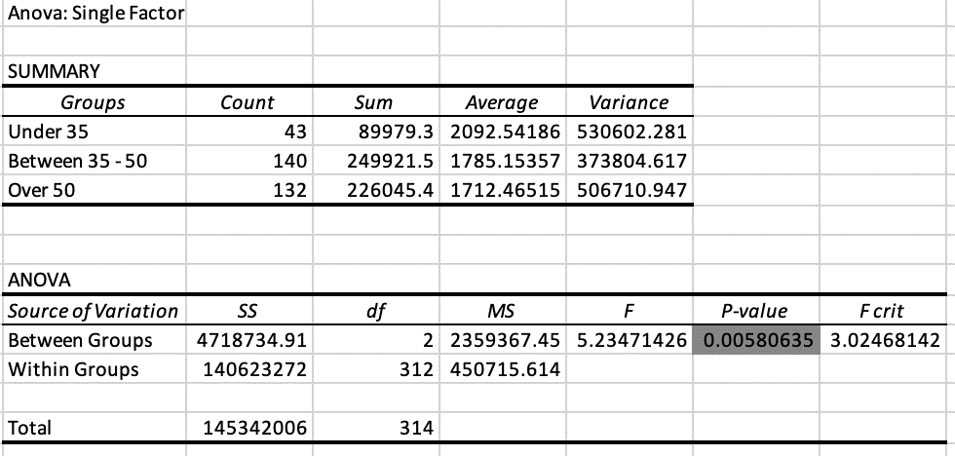
Test 1: Calories Intake vs Age Group

Test 2: Fiber Intake vs Age Group
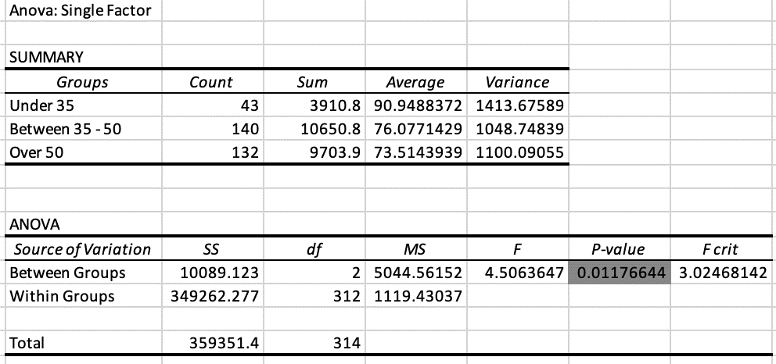

Test3: Fat Intake vs Age Group
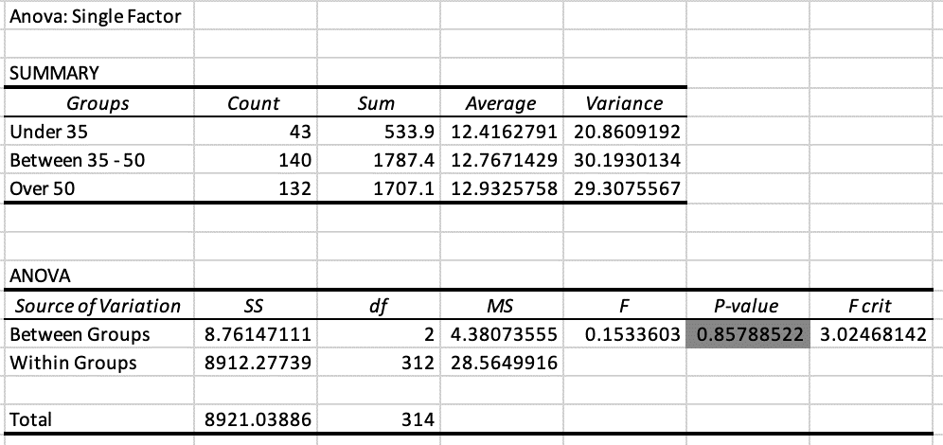

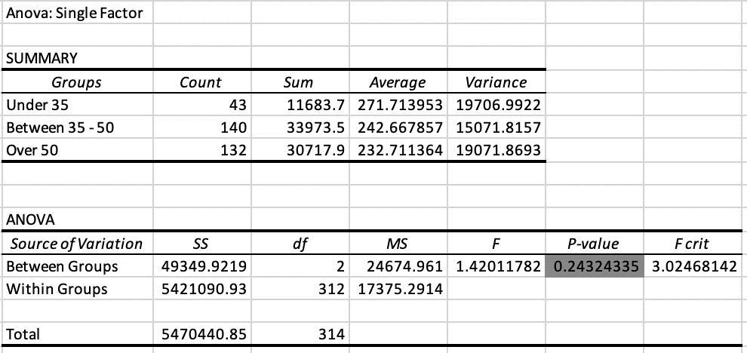
Test 4: Cholesterol Level vs Age Group

Analysis and inference for a one-way ANOVA test: P-Value
Calories & Age | Fiber Intake & Age | Fat Intake &Age | Cholesterol Level vs Age
0.00580635 | 0.01176644 | 0.85788522 | 0.24324335

At the 5% significance level we can conclude that the amount of calories and fat level by age group differs from each other. On the other hand, the mean fat and mean cholesterol level do not differ from each other, we may say that the mean of these variables may assume equal.
Which groups differ with mean calories and fat levels? The Tukey’s Method.

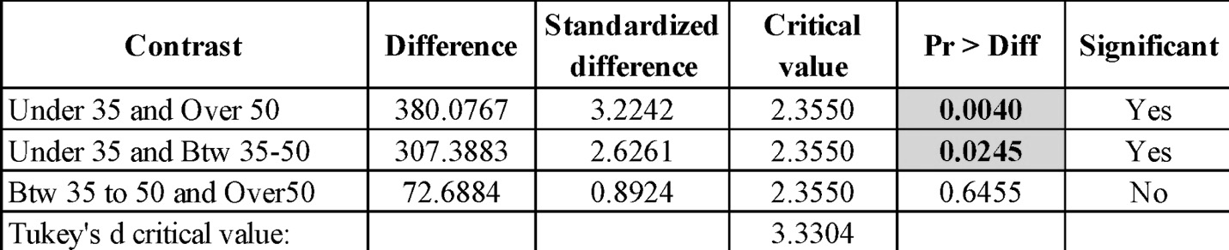

  - Mean calorie intake differ between age group 1 and age group 2, as well as age group 1 and age group 3.

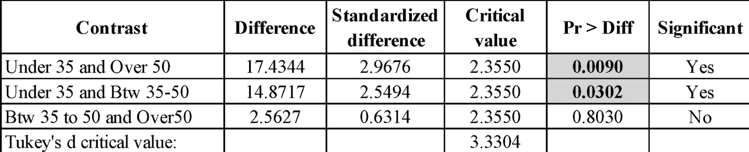

  - Average fat levels differ between age group 1 and age group 2, as well as age group 1 and age group 3.

Two-way ANOVA with interaction:

Test for interaction of cholesterol levels with smoking habits and age group:

  - H0: There is no significant interaction of cholesterol levels among smokers and nonsmokers and different age groups.
  - HA: At least one of the groups differ.

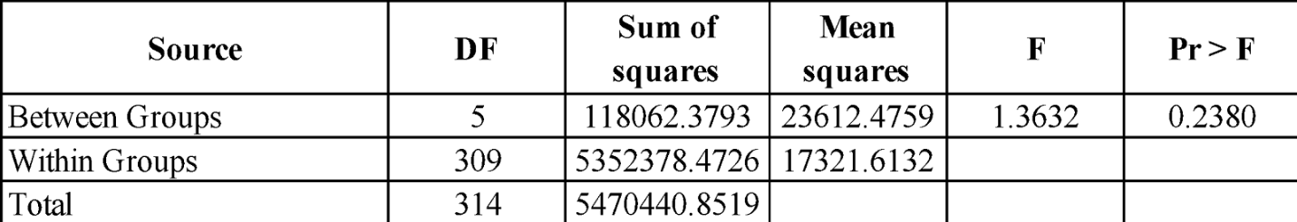

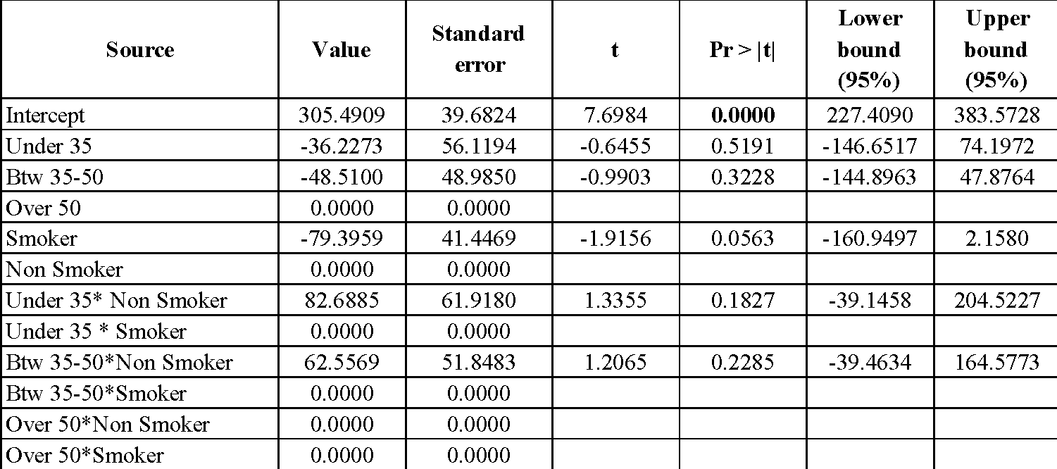

Conclusion: The probability values indicate that cholesterol levels do not interact with smoking habits and any of the age groups.

Regression Model Testing: provides a function that describes the relationship between one or more independent variables and a response, dependent, or target variable. in another word is a way of mathematically sorting out which of those variables does indeed have an impact.
As stated in the report’s goals, we wanted to test if cholesterol can be an excellent choice factor to be the determent of the overall body’s health.
What is cholesterol?
Cholesterol is a waxy, fat-like substance that's found in all the cells in your body. Your body needs some cholesterol to make hormones, vitamin D, and substances that help you digest foods. Your body makes all the cholesterol it needs. Cholesterol is also found in foods from animal sources, such as egg yolks, meat, and cheese.
If you have too much cholesterol in your blood, it can combine with other substances in the blood to form plaque. Plaque sticks to the walls of your arteries. This buildup of plaque is known as atherosclerosis. It can lead to coronary artery disease, where your coronary arteries become narrow or even blocked.
What is HDL, LDL, and VLDL?
HDL, LDL, and VLDL are lipoproteins. They are a combination of fat (lipid) and protein. The lipids need to be attached to the proteins so they can move through the blood. Different types of lipoproteins have different purposes:
- HDL stands for high-density lipoprotein. It is sometimes called "good" cholesterol because it carries cholesterol from other parts of your body back to your liver. Your liver then removes the cholesterol from your body.
- LDL stands for low-density lipoprotein. It is sometimes called "bad" cholesterol because a high LDL level leads to the buildup of plaque in your arteries.
- VLDL stands for very low-density lipoprotein. Some people also call VLDL a "bad" cholesterol because it too contributes to the buildup of plaque in your arteries. But VLDL and LDL are different; VLDL mainly carries triglycerides and LDL mainly carries cholesterol.
What causes high cholesterol?
The most common cause of high cholesterol is an unhealthy lifestyle. This can include:
- Unhealthy eating habits, such as eating lots of bad fats. One type, saturated fat, is found in some meats, dairy products, chocolate, baked goods, and deep-fried and processed foods. Another type, trans fat, is in some fried and processed foods. Eating these fats can raise your LDL (bad) cholesterol.
- Lack of physical activity, with lots of sitting and little exercise. This lowers your HDL (good) cholesterol.
- Smoking, which lowers HDL cholesterol, especially in women. It also raises your LDL cholesterol.
Genetics may also cause people to have high cholesterol. For example, familial hypercholesterolemia (FH) is an inherited form of high cholesterol. Other medical conditions and certain medicines may also cause high cholesterol.
What can raise my risk of high cholesterol?
A variety of things can raise your risk for high cholesterol:
- Age. Your cholesterol levels tend to rise as you get older. Even though it is less common, younger people, including children and teens, can also have high cholesterol.
- Heredity. High blood cholesterol can run in families.
- Weight. Being overweight or having obesity raises your cholesterol level.
- Race. Certain races may have an increased risk of high cholesterol. For example, African Americans typically have higher HDL and LDL cholesterol levels than whites.
What health problems can high cholesterol cause?
If you have large deposits of plaque in your arteries, an area of plaque can rupture (break open). This can cause a blood clot to form on the surface of the plaque. If the clot becomes large enough, it can mostly or completely block blood flow in a coronary artery.
If the flow of oxygen-rich blood to your heart muscle is reduced or blocked, it can cause angina (chest pain) or a heart attack.
Plaque also can build up in other arteries in your body, including the arteries that bring oxygen-rich blood to your brain and limbs. This can lead to problems such as carotid artery disease, stroke, and peripheral arterial disease.
https://medlineplus.gov/cholesterol.html

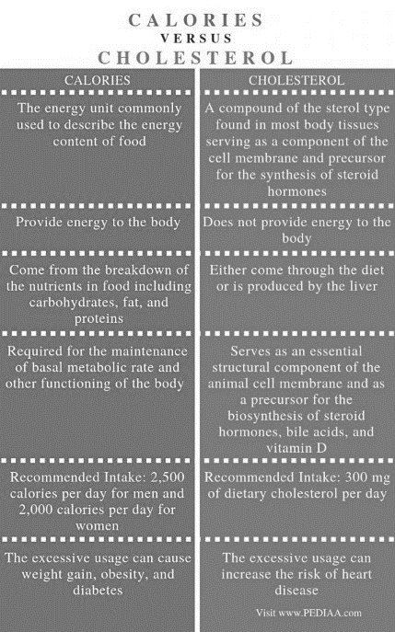
General medical overview about cholesterol and the other variables
- The link between cholesterol and calories:
  - Similarities Between Calories and Cholesterol
- Calories and cholesterol are two parameters responsible for the maintenance of a healthy body.
- Both are essentially important for the functioning of the body as well.
- However, their excessive production may cause health problems in the body.
  - Difference Between Calories and Cholesterol
- Calories refer to the energy unit commonly used to describe the energy content of food, while cholesterol refers to a compound of the sterol type found in most body tissues serving as a component of the cell membrane and precursor for the synthesis of steroid hormones. Thus, this is the main difference between calories and cholesterol.
  - Health affect:
Importantly, the excessive usage of calories can cause weight gain, obesity, and diabetes, while the excessive usage of cholesterol can increase the risk of heart disease.
https://pediaa.com/what-is-the-difference-between-calories-and-cholesterol/#:~:text=The%20main%20difference%20between%20calories,of%20energy%20in%20the%20body.

Cholesterol Potential Risk and Other Variables
Variable | Relationship
Calories | The higher calorie intake the higher cholesterol level
Age | Depends: Recommended cholesterol intake  Age Total cholesterol Non-HDL cholesterol LDL cholesterol HDL cholesterol  19 and younger Below 170 Below 120 Below 110 Above 45  20 and older 125 to 200 Below 130 Below 100 People assigned male at birth: 40 or higher People assigned female at birth: 50 or higher
Fat | The increase in unhealthy fat means increase in calories which will lead to high cholesterol
Fiber | Neutral. But if used wisely can lower the risk of high cholesterol  Cholesterol is a vital substance produced by your body, but high levels of LDL (“bad”) cholesterol are a risk factor for heart disease. Eating fiber may lower cholesterol by lowering the amount of LDL cholesterol in your blood.  https://www.healthline.com/nutrition/fiber-and-cholesterol#cholesterol
Alcohol | While light to moderate alcohol intake isn’t usually harmful, heavy alcohol use can cause severe effects. In fact, heavy alcohol use is one of the leading risk factors for disease burden worldwide, increasing the risk of certain cancers, liver disease, and heart disease  https://www.healthline.com/health/high-cholesterol/effects-of-alcohol#effects
Vitamin Use | Vitamin supplement can help lowering high cholesterol  Niacin is a B vitamin that can help lower cholesterol. A person can also take other dietary supplements, such as berberine and fish oil, to help lower cholesterol. However, people should only use these products after speaking with a doctor.  https://www.medicalnewstoday.com/articles/vitamins-to-lower-cholesterol
Smoking | Smoking can elevate the LDL, or “bad,” cholesterol in your blood and decrease HDL, or “healthy,” cholesterol.  https://www.healthline.com/health/smoking-and-cholesterol#summary
Gender | It depends  Sex hormones like estrogens (estradiol and estrone) and androgens (testosterone and androstenedione) affect cholesterol levels differently in men and women. Your body needs cholesterol to make important steroid hormones like estrogen and progesterone as well as vitamin D.  In general, between the ages of 20 and 55 years, men tend to have higher LDL and lower HDL cholesterol levels than women. However, after the age of 55, women’s HDL cholesterol levels decrease rapidly, and LDL levels rise. This is due to menopause.  https://goforward.com/blog/heart-health/how-does-high-cholesterol-affect-women-and-men-differently#:~:text=Male%20vs%20Female%3A%20Sex%20hormones%20and%20cholesterol%

Research methodology
After we read some medical facts about the link between cholesterol and other factors, we believe a cholesterol test is essential in assessing overall health. High cholesterol levels often are a significant risk factor for heart attacks and other forms of heart disease and diseases of the blood vessels.
To get to our goal we will be testing the data by using Multivariate Regression Analysis.

Multivariate Regression Analysis:
This is a method used to measure the degree at which more than one independent variable (predictors) and more than one dependent variable (responses), are linearly related.
General guidelines to interpret test results

Cholesterol Level
Below 200 mg/dL | Desirable
200-239 mg/dL | Borderline high
240 mg/dL and above | High

Objective:
- To estimate the effect of nutritional factors like Calories, Fat, Gender, Age, Alcohol, Smoker/Nonsmokers and Vitamin Use on Cholesterol.

Hypothesis:
  - H0: All coefficients in the model are equal to zero. None of the independent variables have a significant relationship with cholesterol.

  - HA: At least one variable has an effect.

Bivariate Correlation Plot:
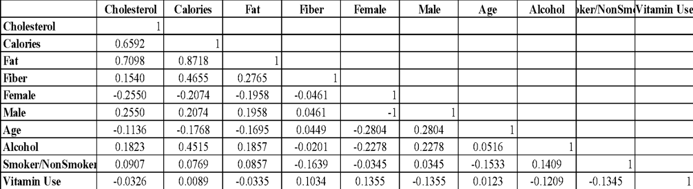
- The dependent variable Cholesterol is highly correlated with Calories and Fat followed by a relatively low correlations with rest of the factors.

- The independent variables Fat, Calories and Alcohol are correlated among each other indicating there could be multicollinearity. A VIF of 5 and below is considered as a cutoff for the model.
Model Assumptions:
- Residuals are linear
- There is no multicollinearity
- Error term is the same for all observations, there is no heteroskedasticity.
- There is no autocorrelation
- There is no endogeneity
- Errors are normally distributed.
Testing the individual significance of each independent variable, prioritizing variables with high correlations moving towards lower ones.

Individual Significance and Coefficients:
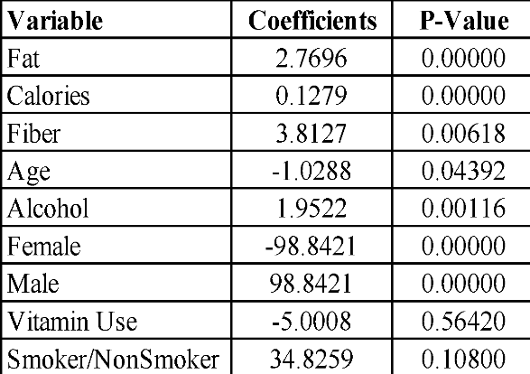

Level of Significance
- 5% level of significance
Decision Rule:
- If the p value is higher than the significance level, the null hypothesis is not refuted, and the results are not statistically significant.
- If the p value is lower than the significance level, the results are interpreted as refuting the null hypothesis and reported as statistically significant
Results:
  - The P-values indicate fat, calories, fiber, alcohol, age and gender significantly impact cholesterol levels.
  - Vitamin Use and smoking habits are not significant in explaining cholesterol levels.

Testing the joint significance by prioritizing variables with high correlations that were individually significant.
Goodness of fit statistics for the joint model:

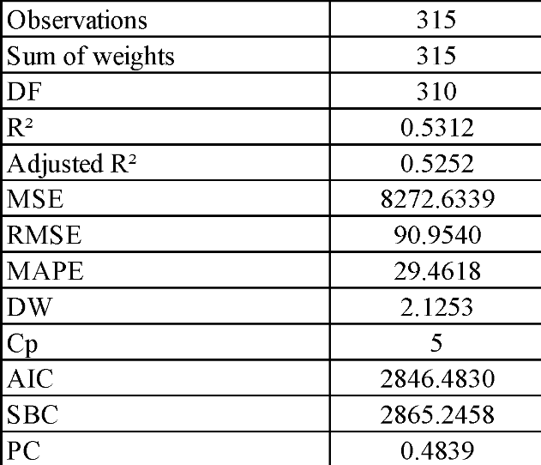

Model Parameters:

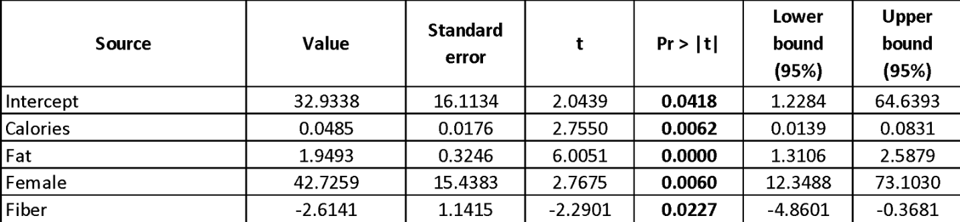

Model:
Cholesterol = 32.9338+0.0484*Calories+1.9492*Fat-2.6140*Fiber+42.7259*Female Dummy

Interpretation:
Fat, Calories, Fiber and Gender jointly impact cholesterol with fat being highly significant followed by gender, calories and fiber.
The model coefficients indicate:
One milligram increase in fat contributes to 1.94 milligrams of increase in cholesterol.
One kilo increase in calories contributes to 0.04 milligrams of increase in cholesterol.
Gender is associated with high levels of cholesterol.
One gram increase in fiber leads to 2.61 milligrams of decrease in cholesterol.

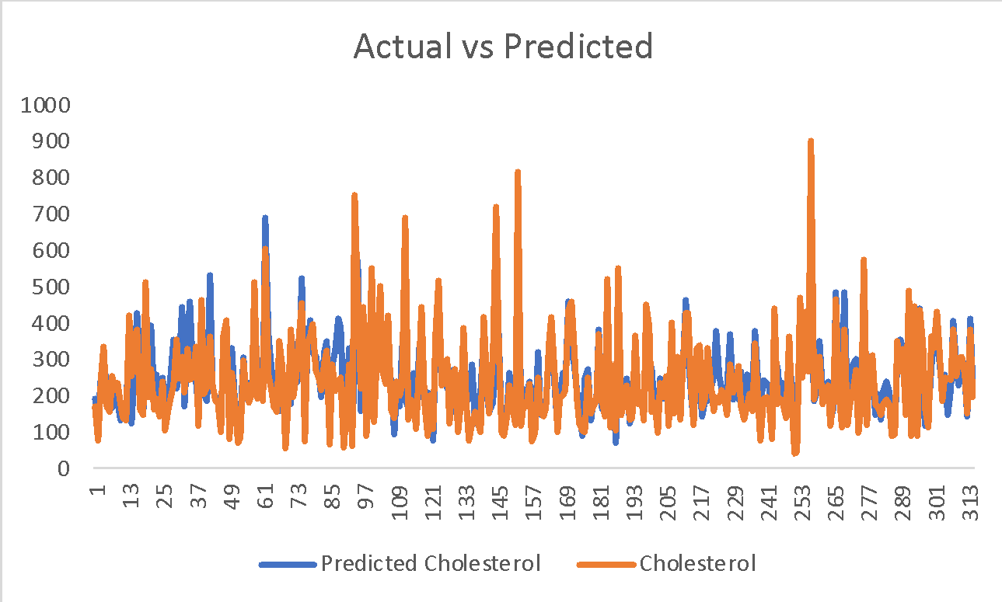

53% of variation is explained by independent variables in explaining cholesterol

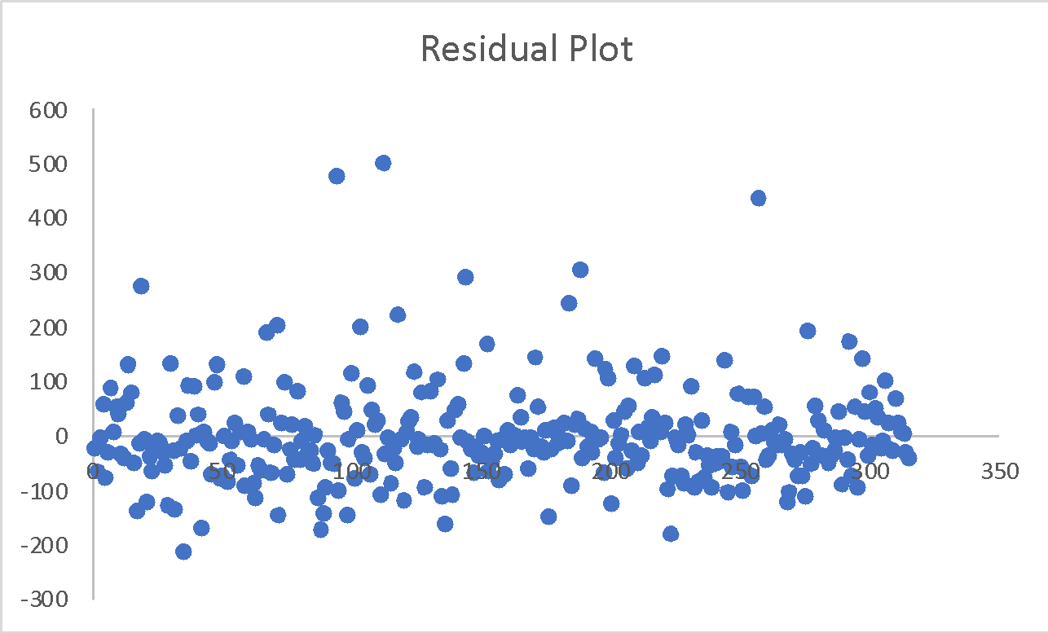

Errors are normal with a few outliers. The outliers seemed to be normal across variables and did not seem like a data entry error, these extreme observations looked like the data from patients who were overweight. However, we do not have weight related data available to relate to the extreme observations. This regression model is built without treating for outliers. Outliers can be influential observations.
Binary Logistic Regression Analysis
This is a process of modeling the probability of a discrete outcome given an input variable. The most common logistic regression models a binary outcome; something that can take two values such as true/false, yes/no, and so on.
Objective: What is the probability that a patient is going to be a cholesterol high risk patient given other factors like Calories, Fat, Gender, Age, Alcohol, Smoker/Nonsmokers and Vitamin Use.
General guidelines to interpret cholesterol test results
Cholesterol Level
Below 200 mg/dL | Desirable
200-239 mg/dL | Borderline high
240 mg/dL and above | High

- For the Binary Logistic Regression Model, we considered these cutoffs. Observations for which cholesterol levels were below 200 were categorized as 0(Low Risk) and cholesterol levels of over 200mg were categorized as 1(High Risk).

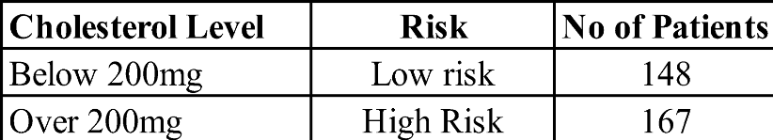

Hypothesis:
Null Hypothesis: All the coefficients of the regression model are equal to zero. None of the independent variables are significant in explaining the probabilities.
Alternative Hypothesis: At least one of the variables is significant in explaining the probabilities.

The Predicted probability model:
Pr (Chol risk=1) = 1 / (1 + exp (-6.124600+0.004001*Calories-0.149103*Fiber+0.025981*Age)))

Model Parameters:
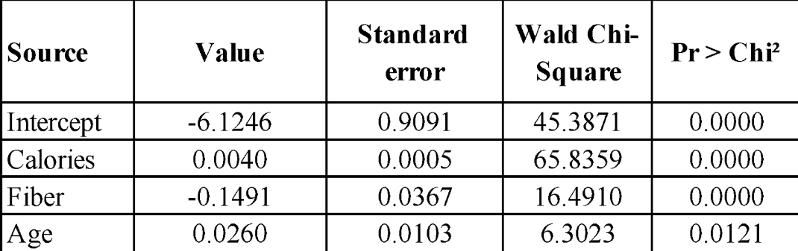

Inference:

  - The regression coefficients for calories and age being positive indicate positive influence on the probabilities.
  - The regression coefficients of fiber is negative indicating negative influence on the probabilities.

Changing Impact, an illustration:

 | Calories | Fiber | Age
Minimum | 445.2 | 3.1 | 19
Maximum | 6662.2 | 36.8 | 83
Average | 1796.7 | 12.8 | 50

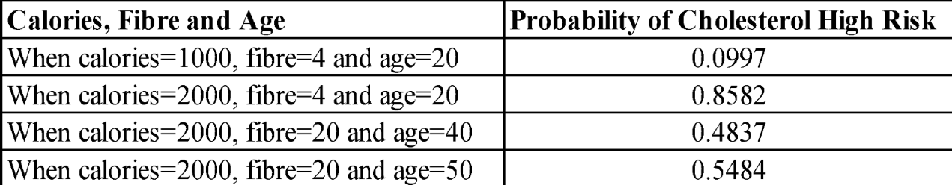

Comparison of first two cases: Probability of risk increases by 0.7585 when calorie consumption increases by twice the amount with same age and same fiber intake.

Comparison of Last two cases: On the other hand, with increase in age probability of risk increases by only 0.0648 when consuming same amount of calories and fiber.

Classification table:

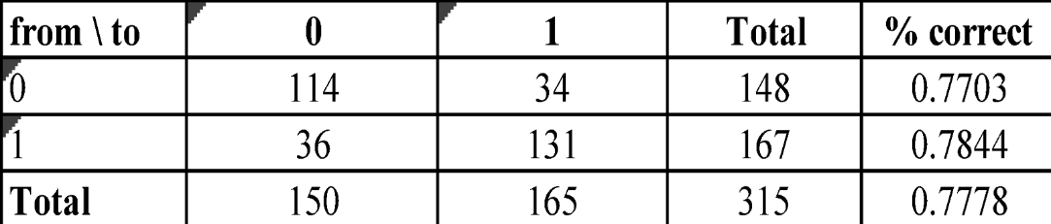

Out of 167 observations related to high cholesterol levels 78.44% (131 records) were classified correctly.

Conclusion
In this report we conducted various hypothesis tests as well as developed multiple regression models and as a result, we have come to the conclusion that variables like age, alcohol intake, smoking status, and vitamin use and even dietary factors including calories, cholesterol, fat, and fiber, do in fact affect a person’s wellbeing. To conduct our analysis, we examined the majority of these variables using the Z-test, T-test, Chi-Square, and ANOVA to see if we would reject the null hypothesis or not.
Our T-Test indicated a significant difference between the nutrients level of male and female except for the case of fiber. Our Chi-square model indicated that smoking, alcohol intake, and vitamin use depend on the age of a person. Our ANOVA analysis concluded that certain nutrient level differ among age as well as calories and fat.
We also utilized a multivariate regression model to examine if the nutritional factors such as calories, fat, alcohol intake, vitamin use. have any effect on one’s cholesterol level. We tested independent variables such as vitamin use, smoke status and age to see if these play a major factor in effecting one’s cholesterol level. At the conclusion of all our analysis, we found that the fat, calories, fiber, alcohol, age and gender significantly impact cholesterol levels while vitamin use, and smoking habits are not significant in explaining cholesterol levels. And we used a logistic regression model to test the probability that a patient is going to be a cholesterol high risk given other factors like Calories, Fat, Gender, Age, Alcohol, Smoker/Nonsmokers and Vitamin Use.
To conclude this report, there are numerous techniques to assess and understand this nutrition data, however we are confident that every analysis and test conducted were useful for prediction and checking the relationship between variables. As a team of independent researchers engaged in this nutrition study, we anticipate further exploring these hypotheses to contrast the outcomes.

